#Logging in AWS

#Create AMI Rule

#Create AMI Policy for the Rule (or Create AMI policy and attach to AMI Rule

#Create S3 Bucket

#Create EC2 Instance while selecting AMI Rule or create EC2 Instance and then Add AMI rule after creating EC2 Instance

#Install AWS in EC2

#Create Shell Script inside EC2

#Add the script in the cron for schedule run

<https://aws.amazon.com/>

1. Open the AWS URL: <https://aws.amazon.com/>

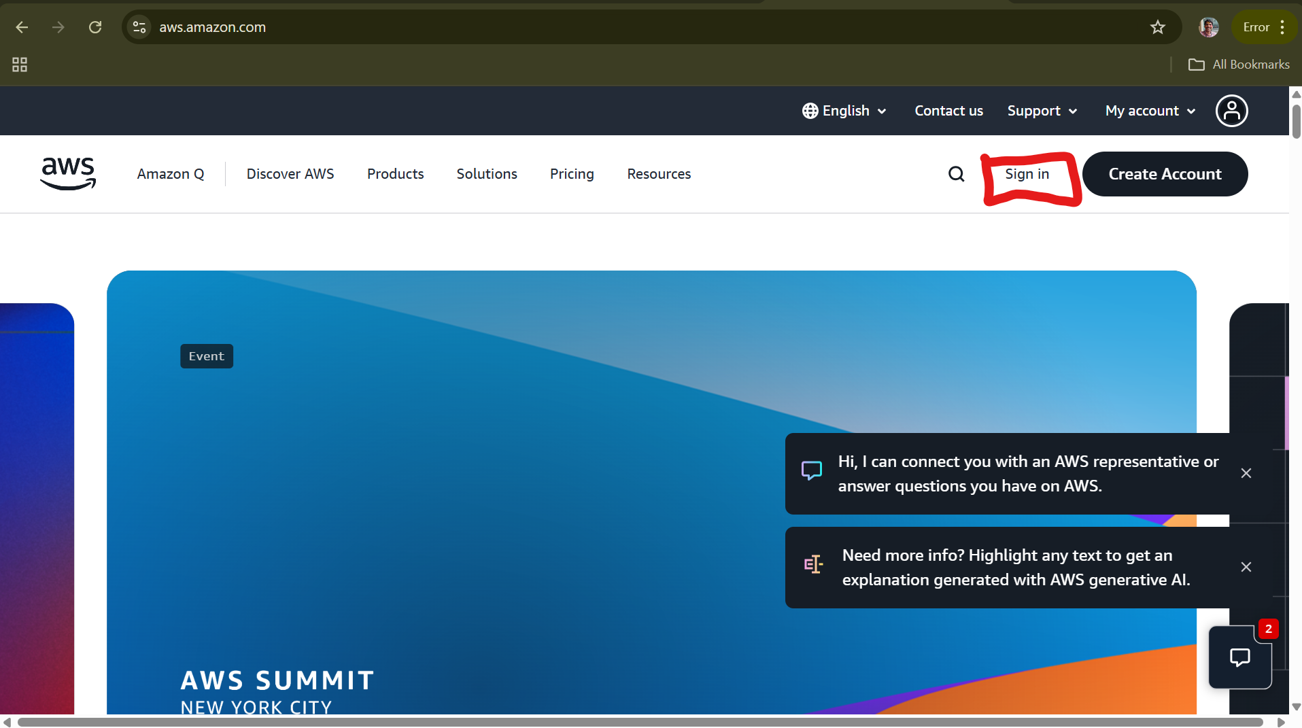

1. Click on Sign in

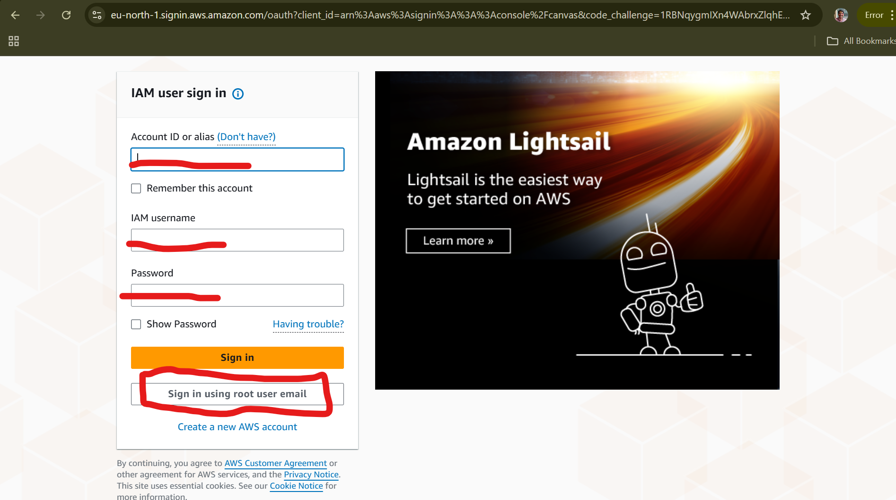

1. Either Sign in with IAM User or Sign in using root user email. For this instance, I am logging with root user by clicking on **sign in using root user email and** Click on **Next.**

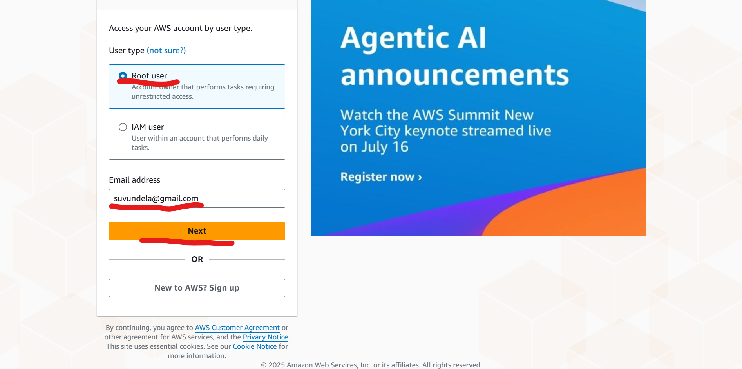

1. Enter the password and click on Sign.

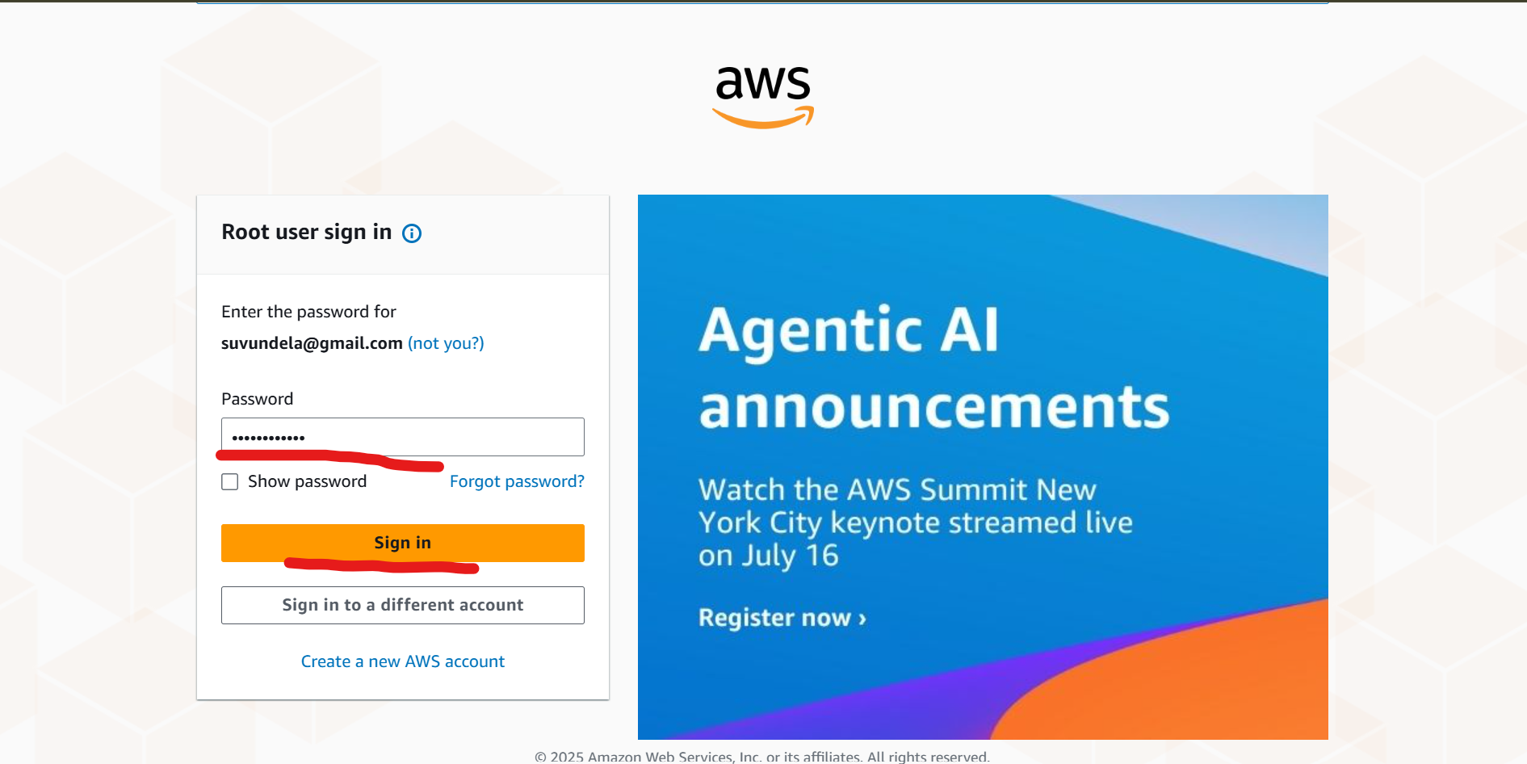

1. You will be logging into Console Home as shown below screenshot.

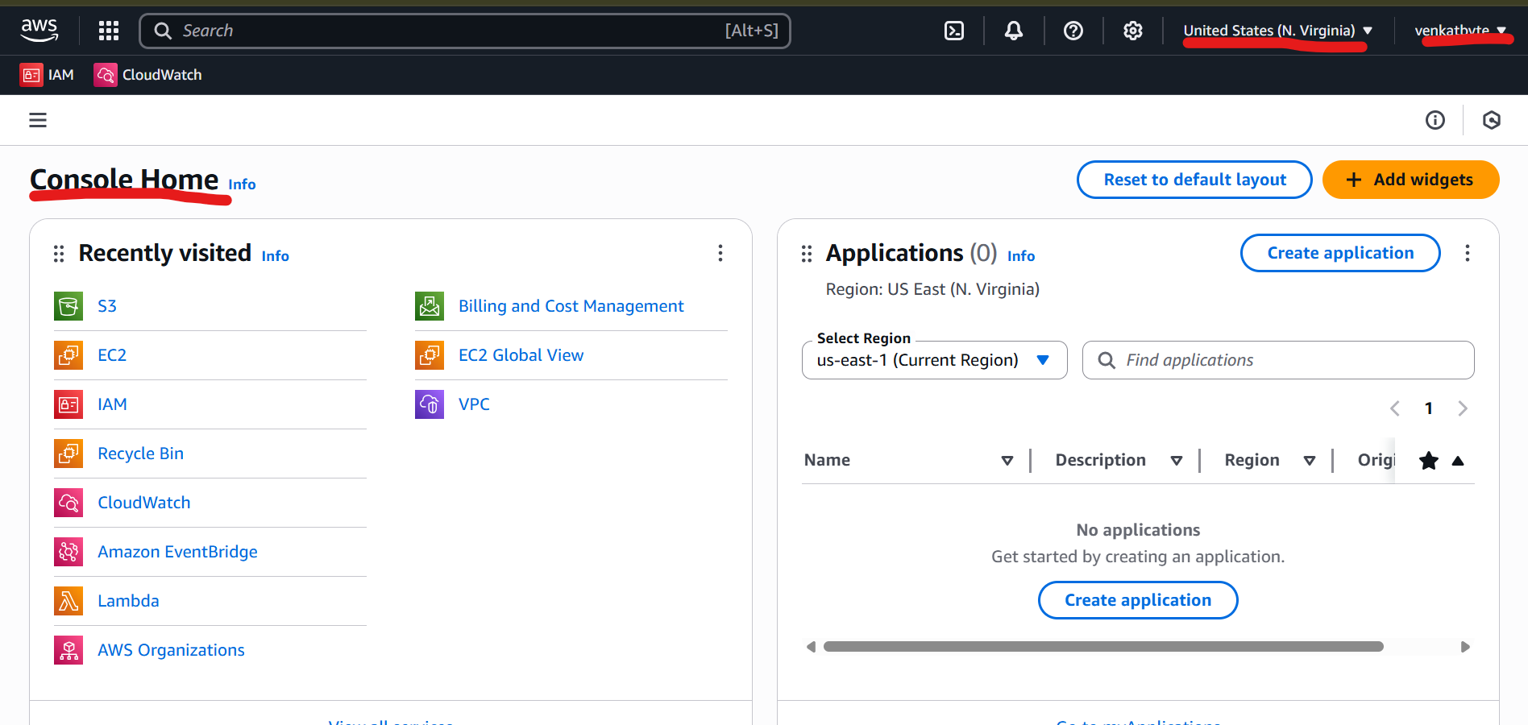

1. Next, we are going to create IAM rule for the EC2 to take AMI Images and Upload it to S3 Bucket.

In order to create IAM role, enter the IAM in the Search.

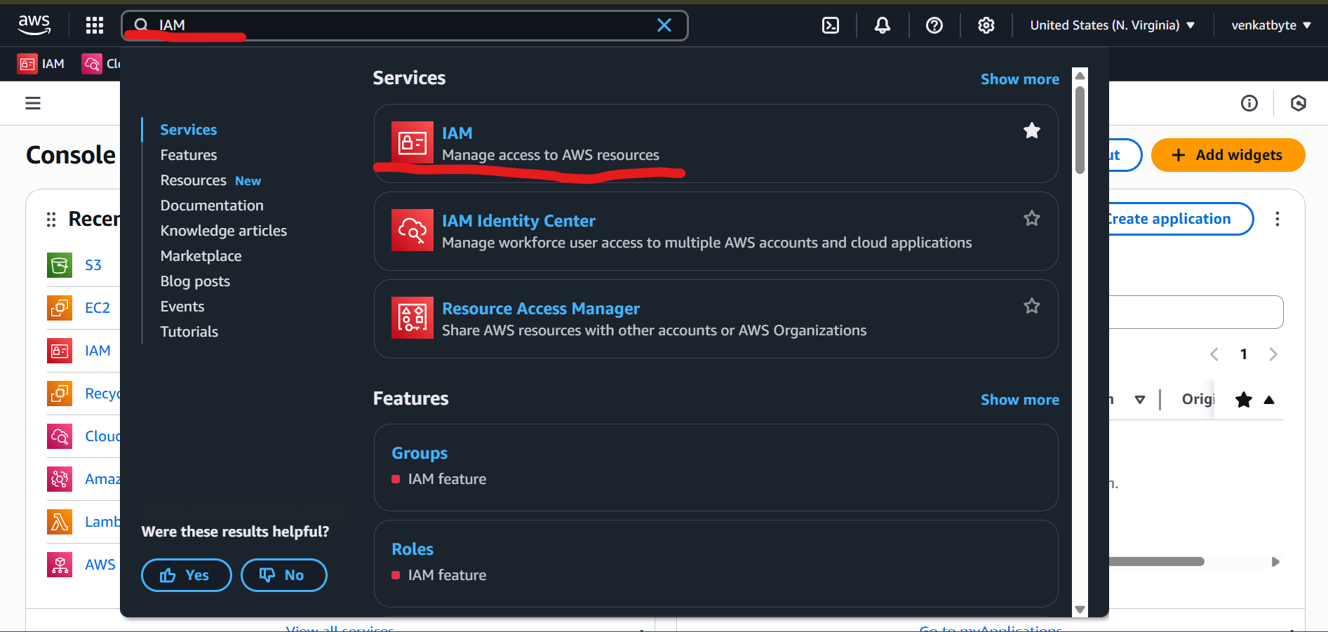

1. Click on IAM in the Services. You will be redirected to IAM > Dashboard. Then Click on Roles.

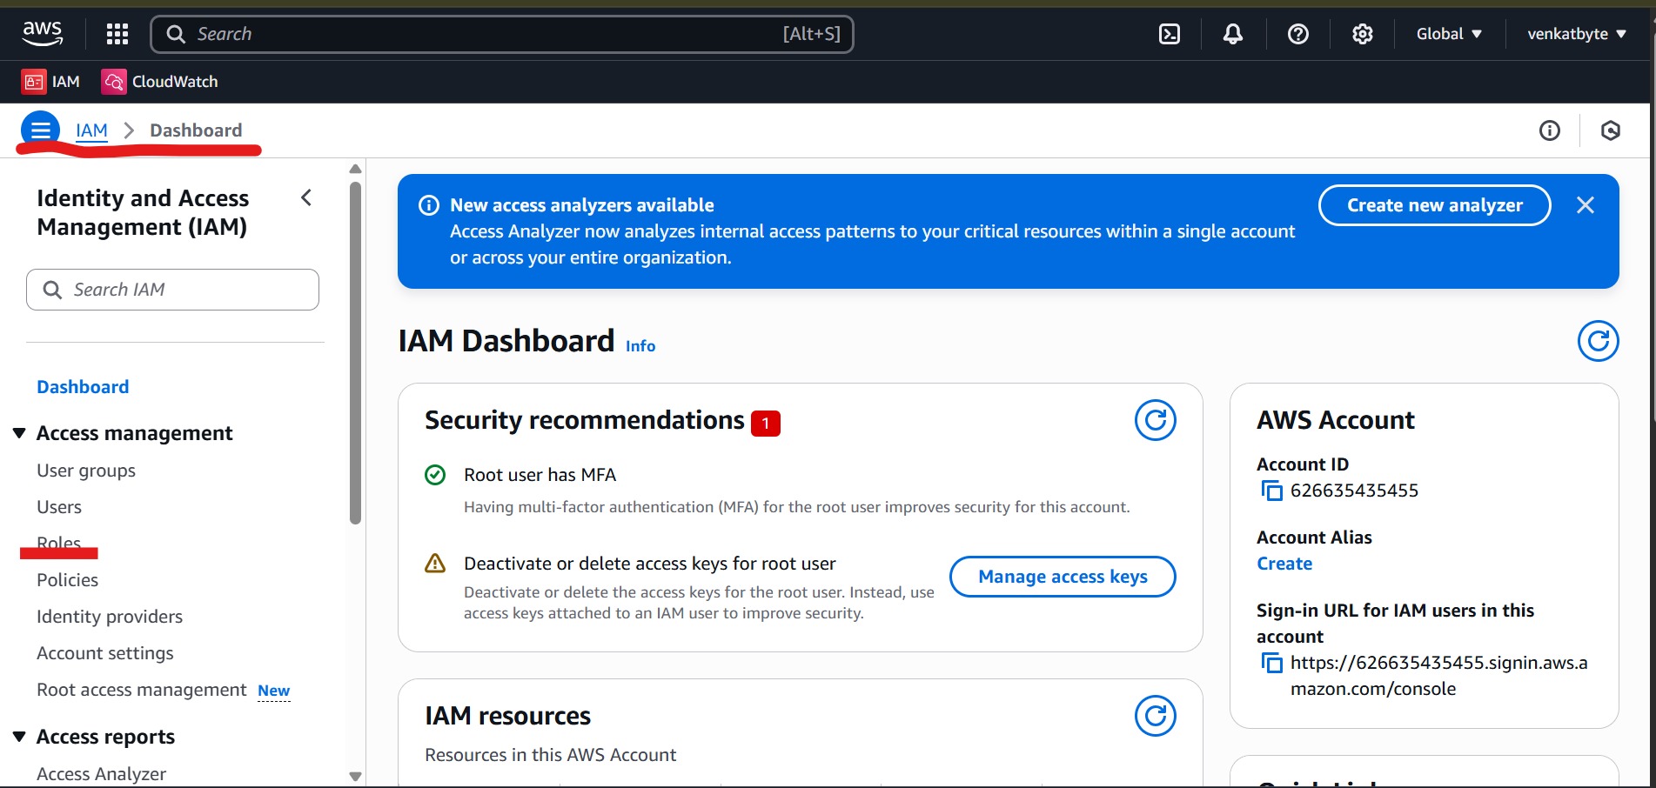

1. You will be redirected to Roles IAM > Roles. Click on Create role

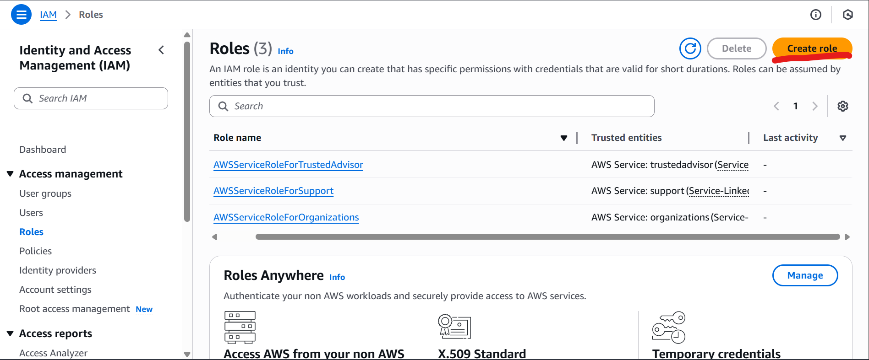

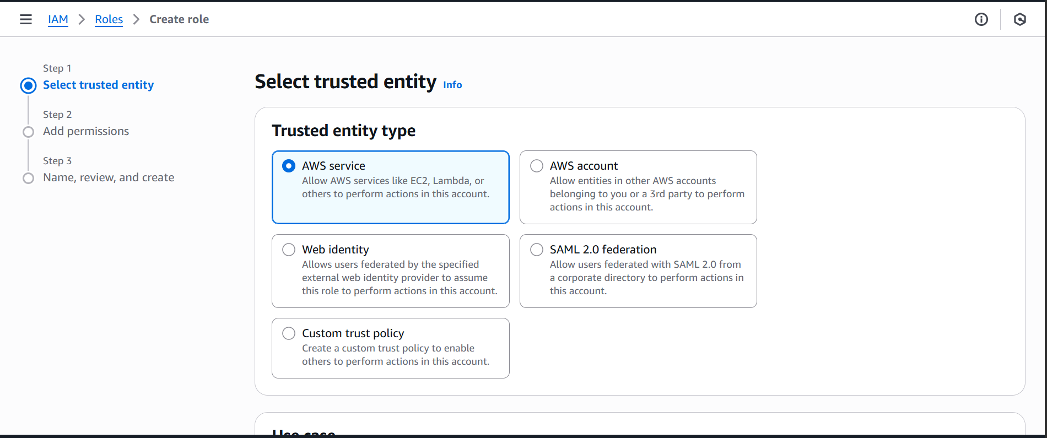

1. Select trusted entity as AWS service and Choose a service as EC2 from Use Case drop down and click Next

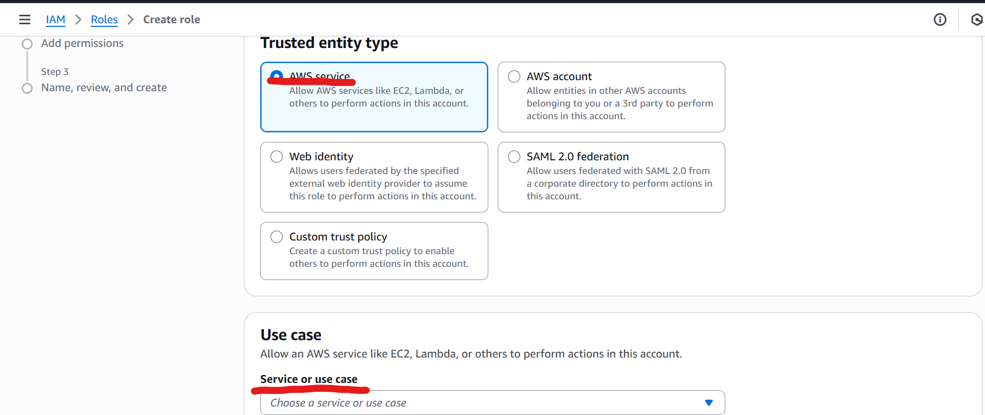

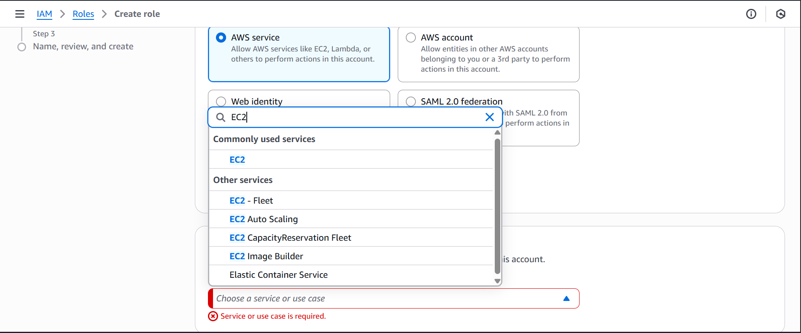

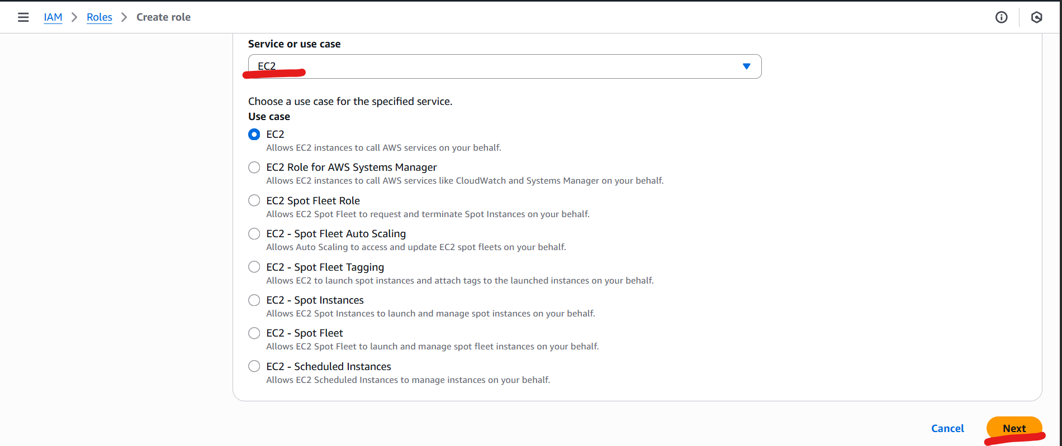

1. Next Step is Permission Policies (Do not select any policy), just drag down to bottom of the screen and click Next.

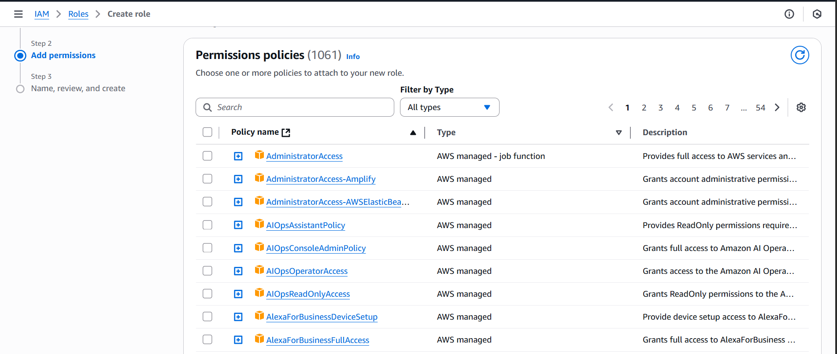

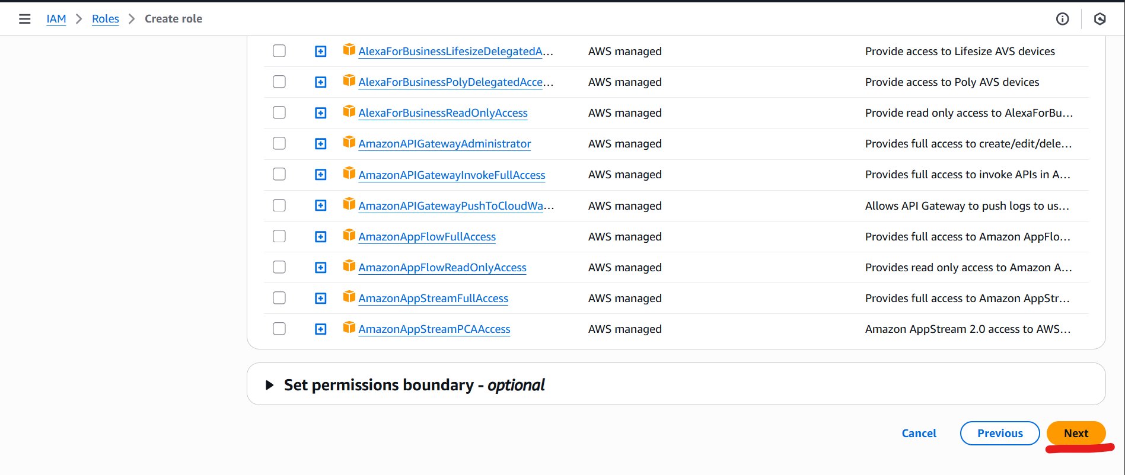

1. Provide the rule name and scroll down to last and select create role.

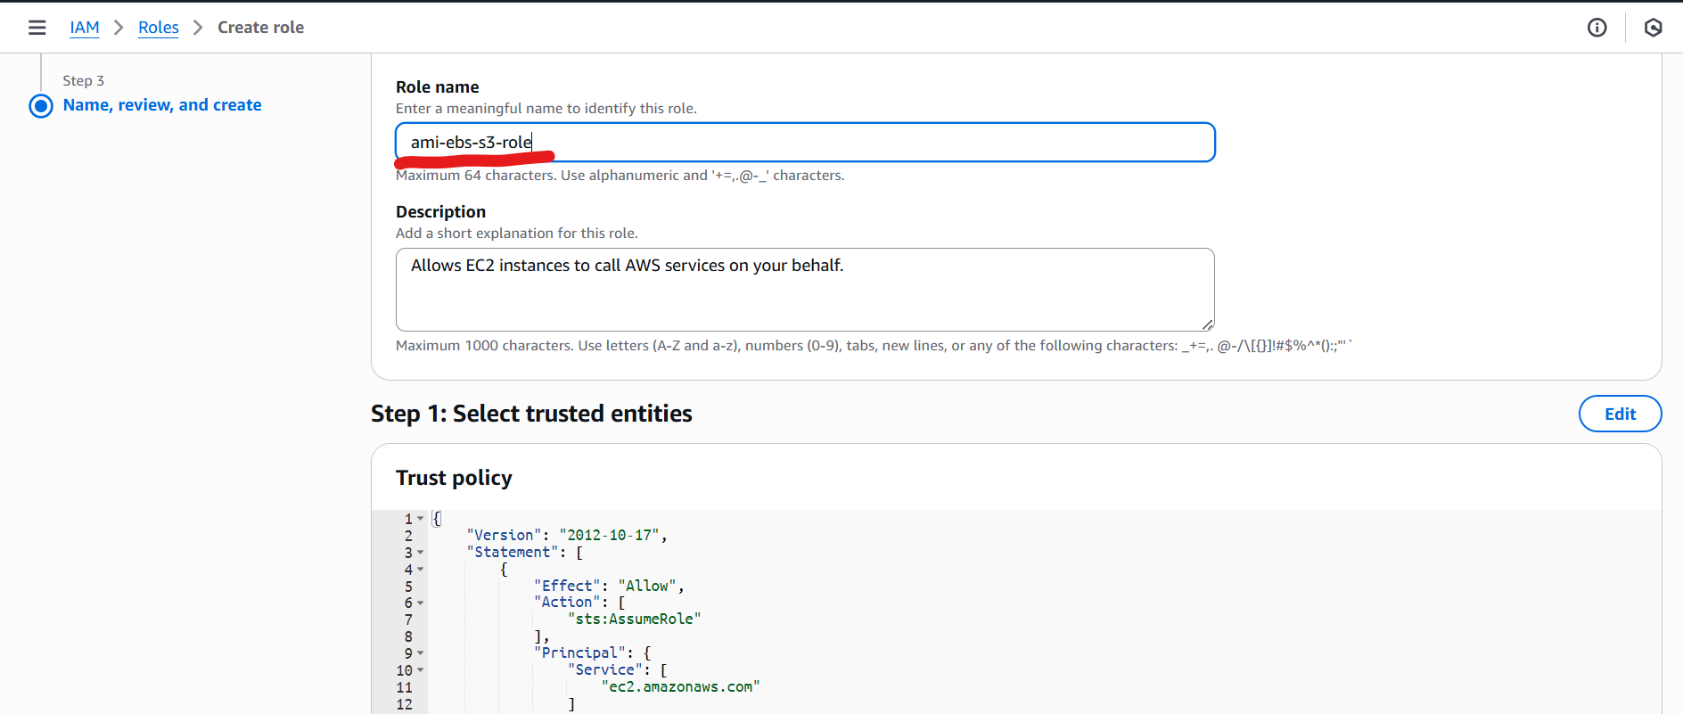  
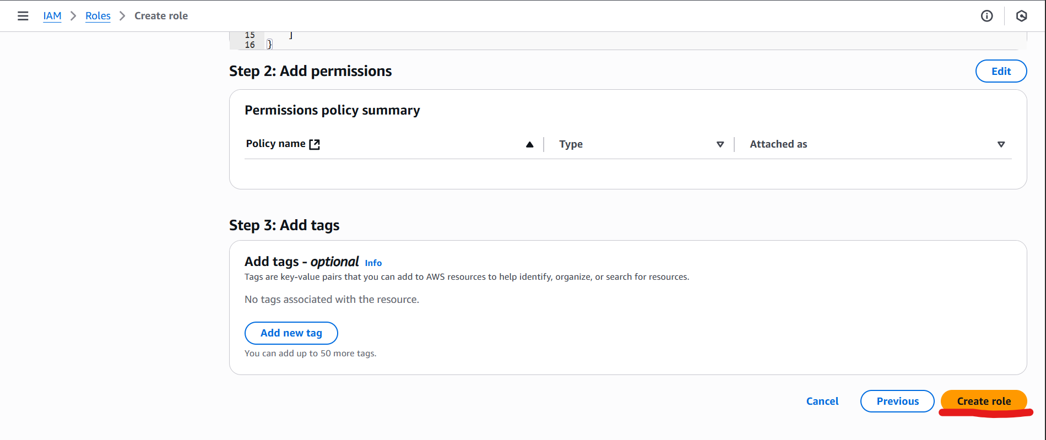

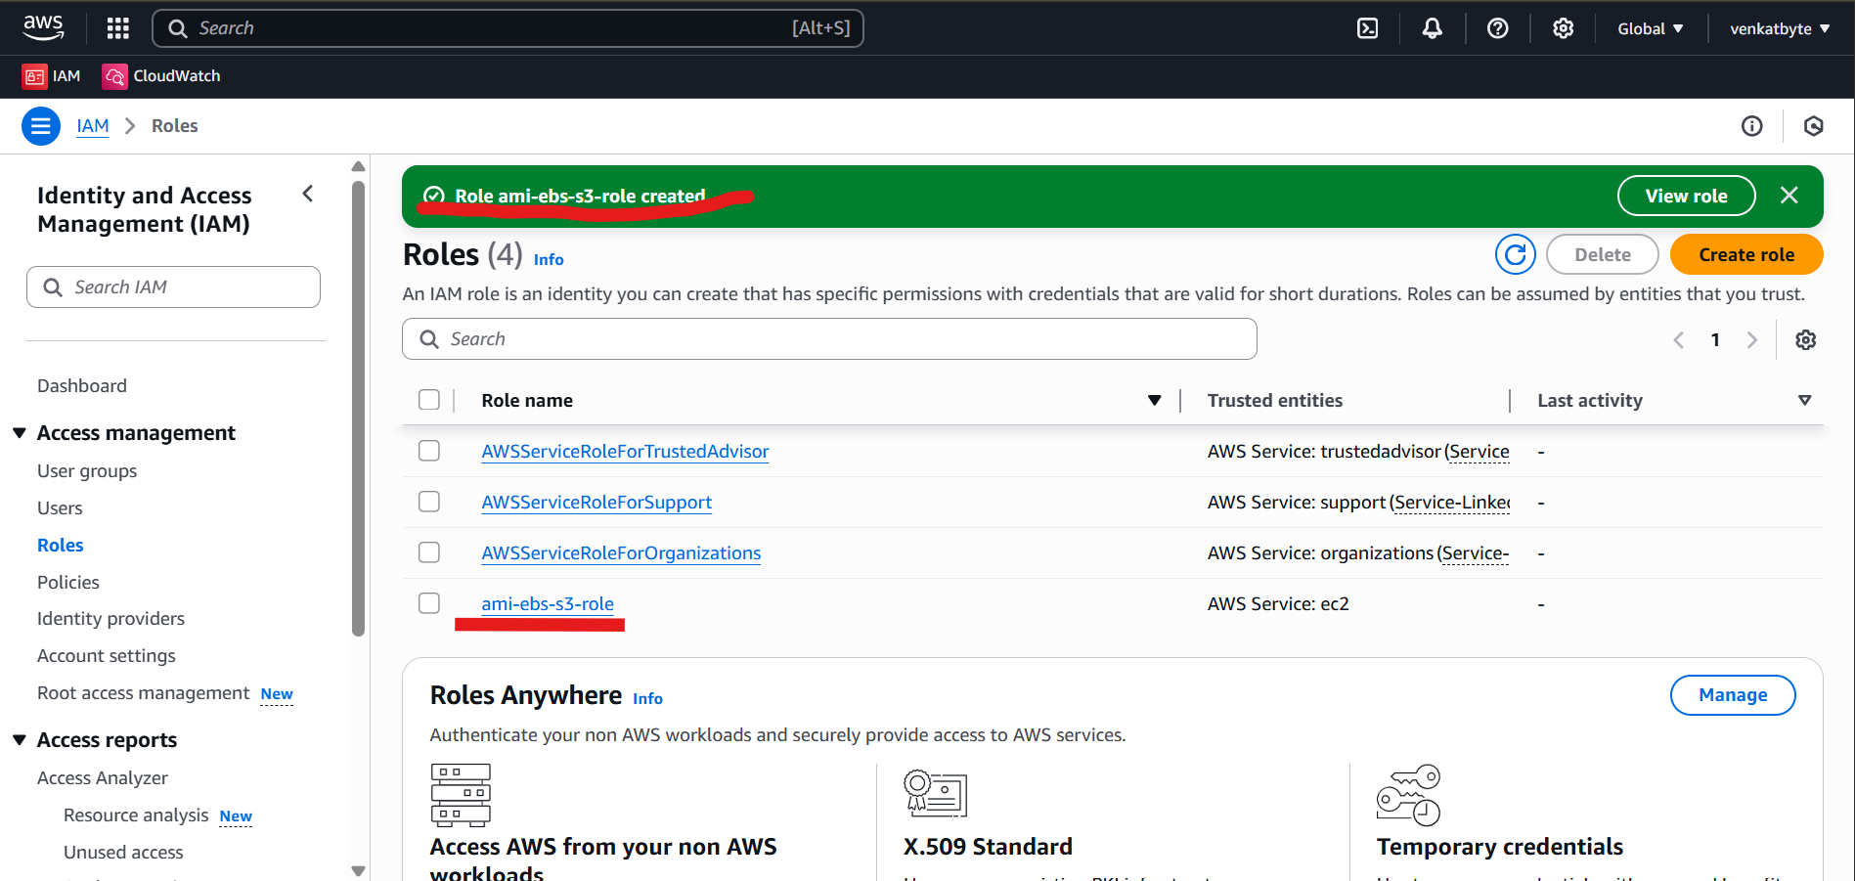

1. Select the newly created role ami-ebs-s3-role to define the custom policy (permissions) to the role.

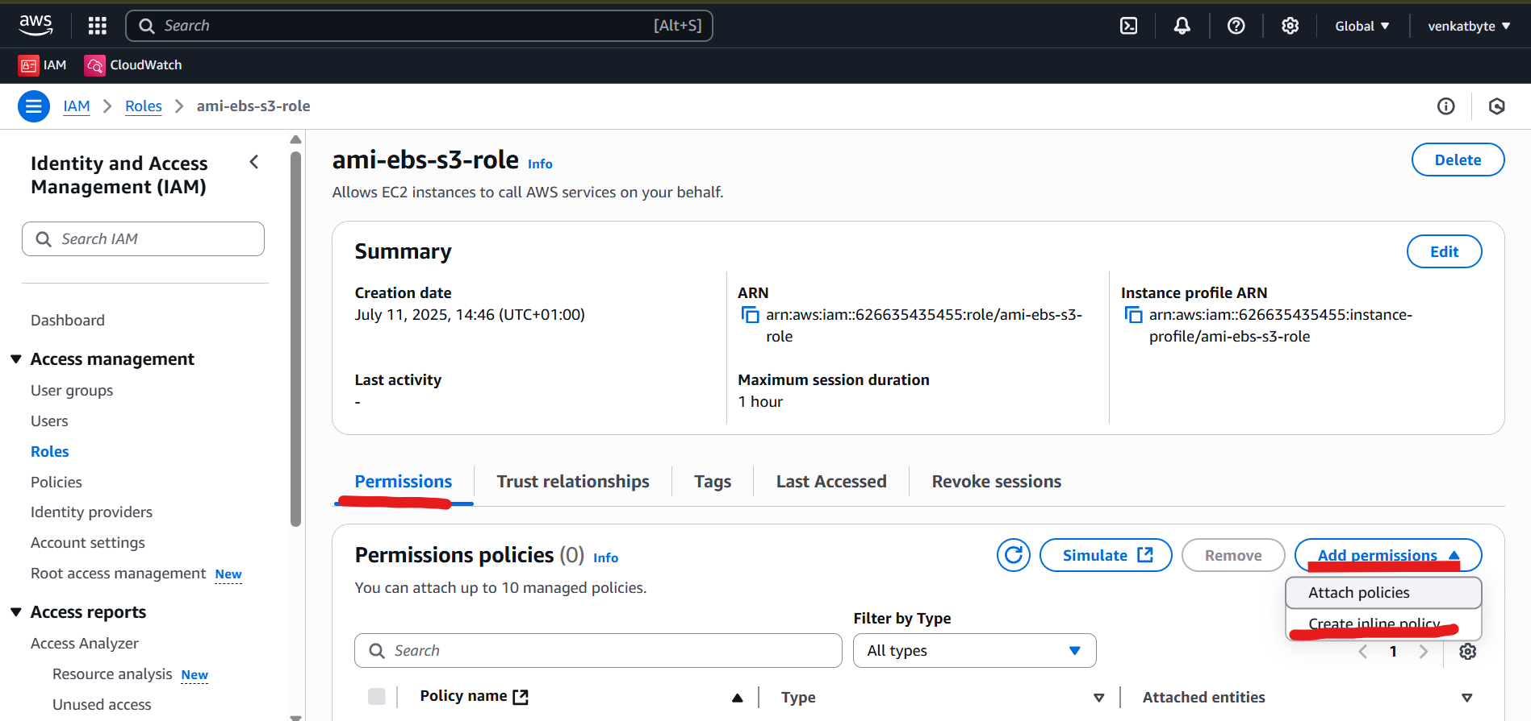

1. Select Permissions and Click Create inline policy from Drop down of Add permission

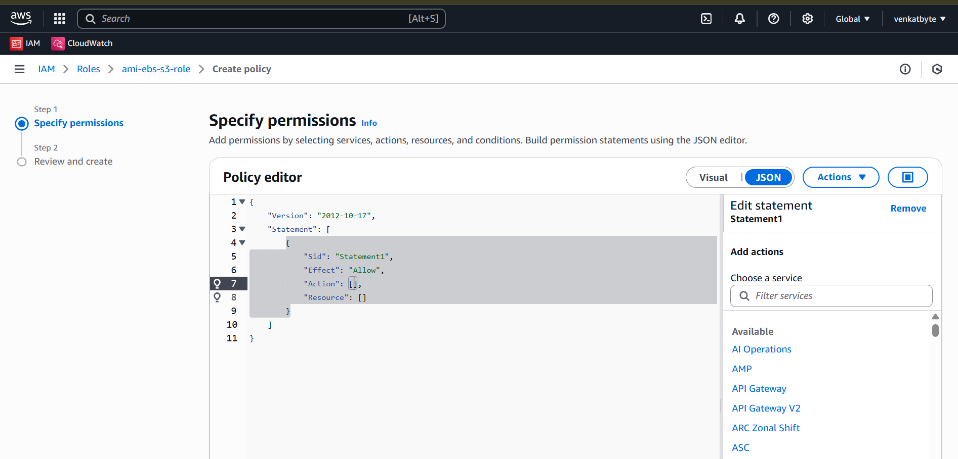

1. Select JSON Policy editor in the Specify permissions and copy paste below json custom policy from VENKATBYTE GitHub. And scroll last and click Next.

<https://raw.githubusercontent.com/venkatbyte/aws-ami-store-s3/refs/heads/main/iam-rule-policy-for-ec2.json>

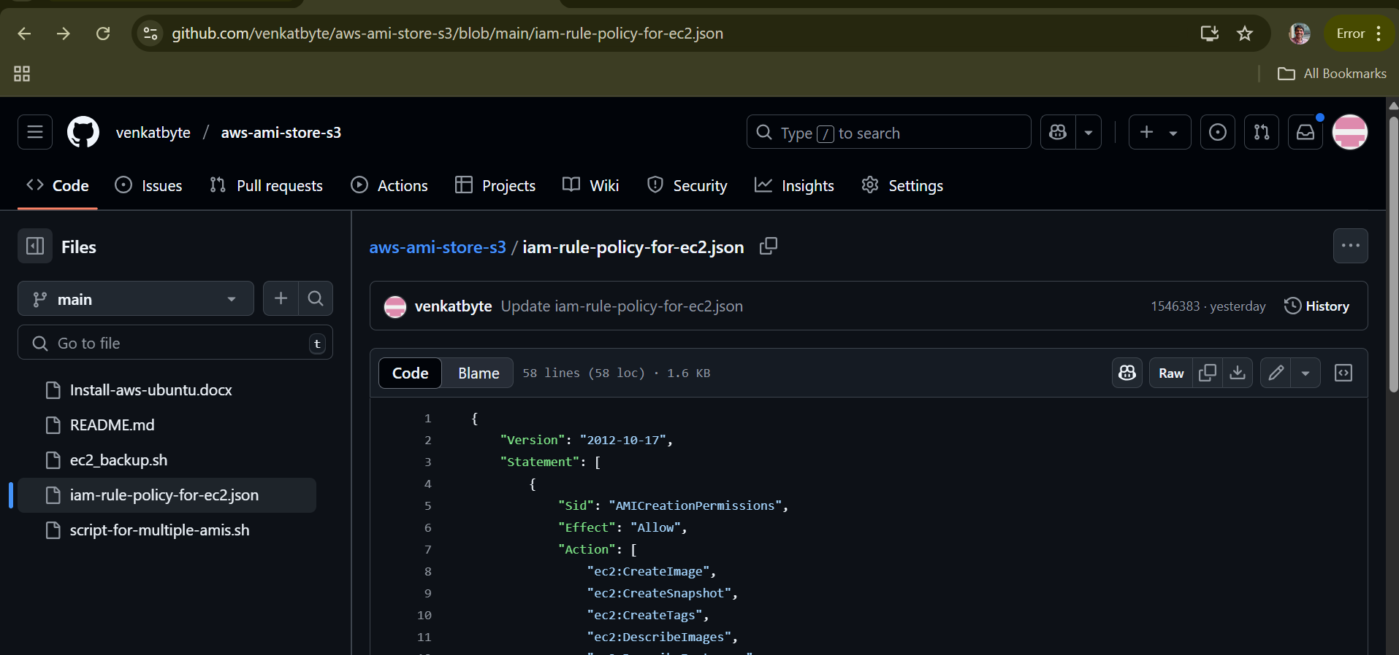

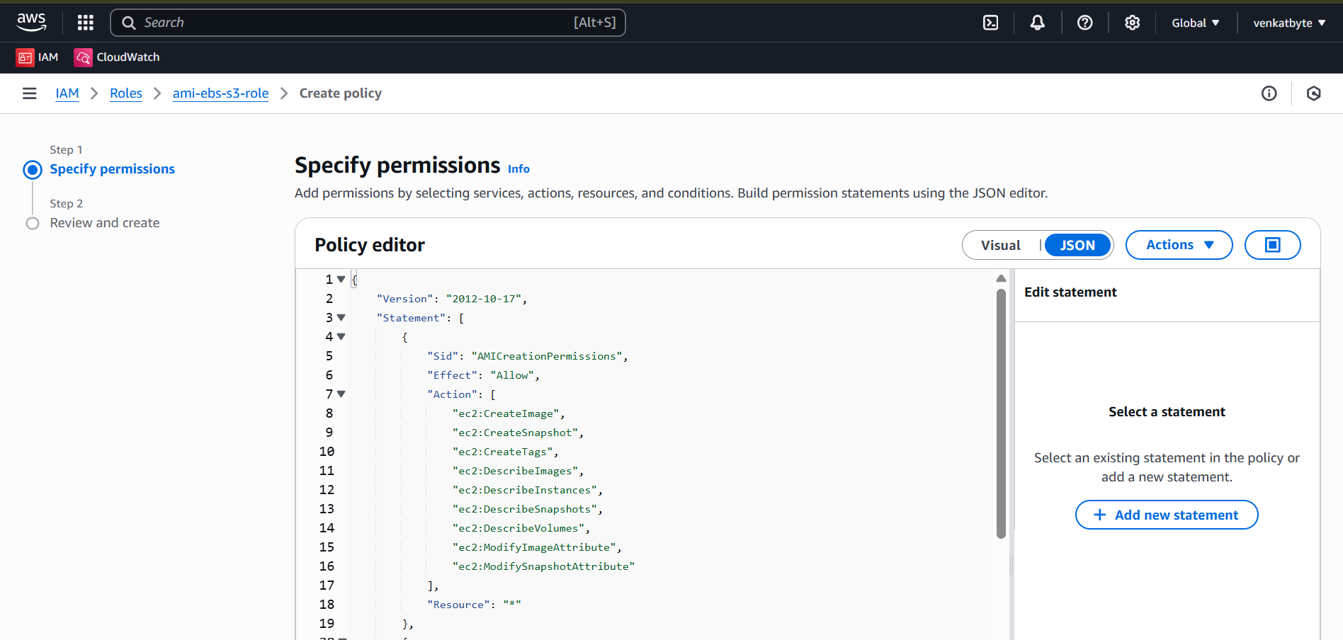

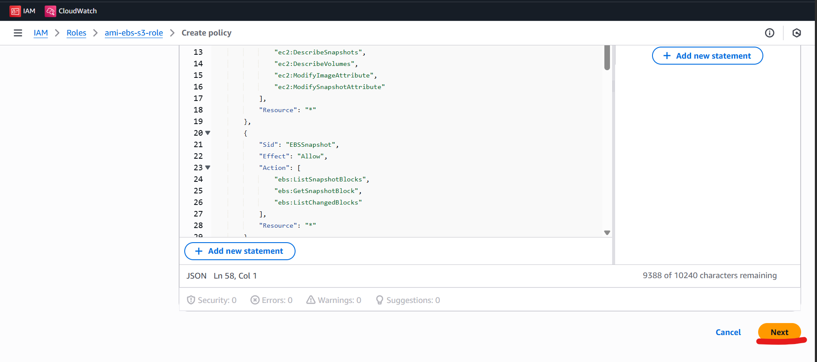

1. Provide policy name and click create policy.

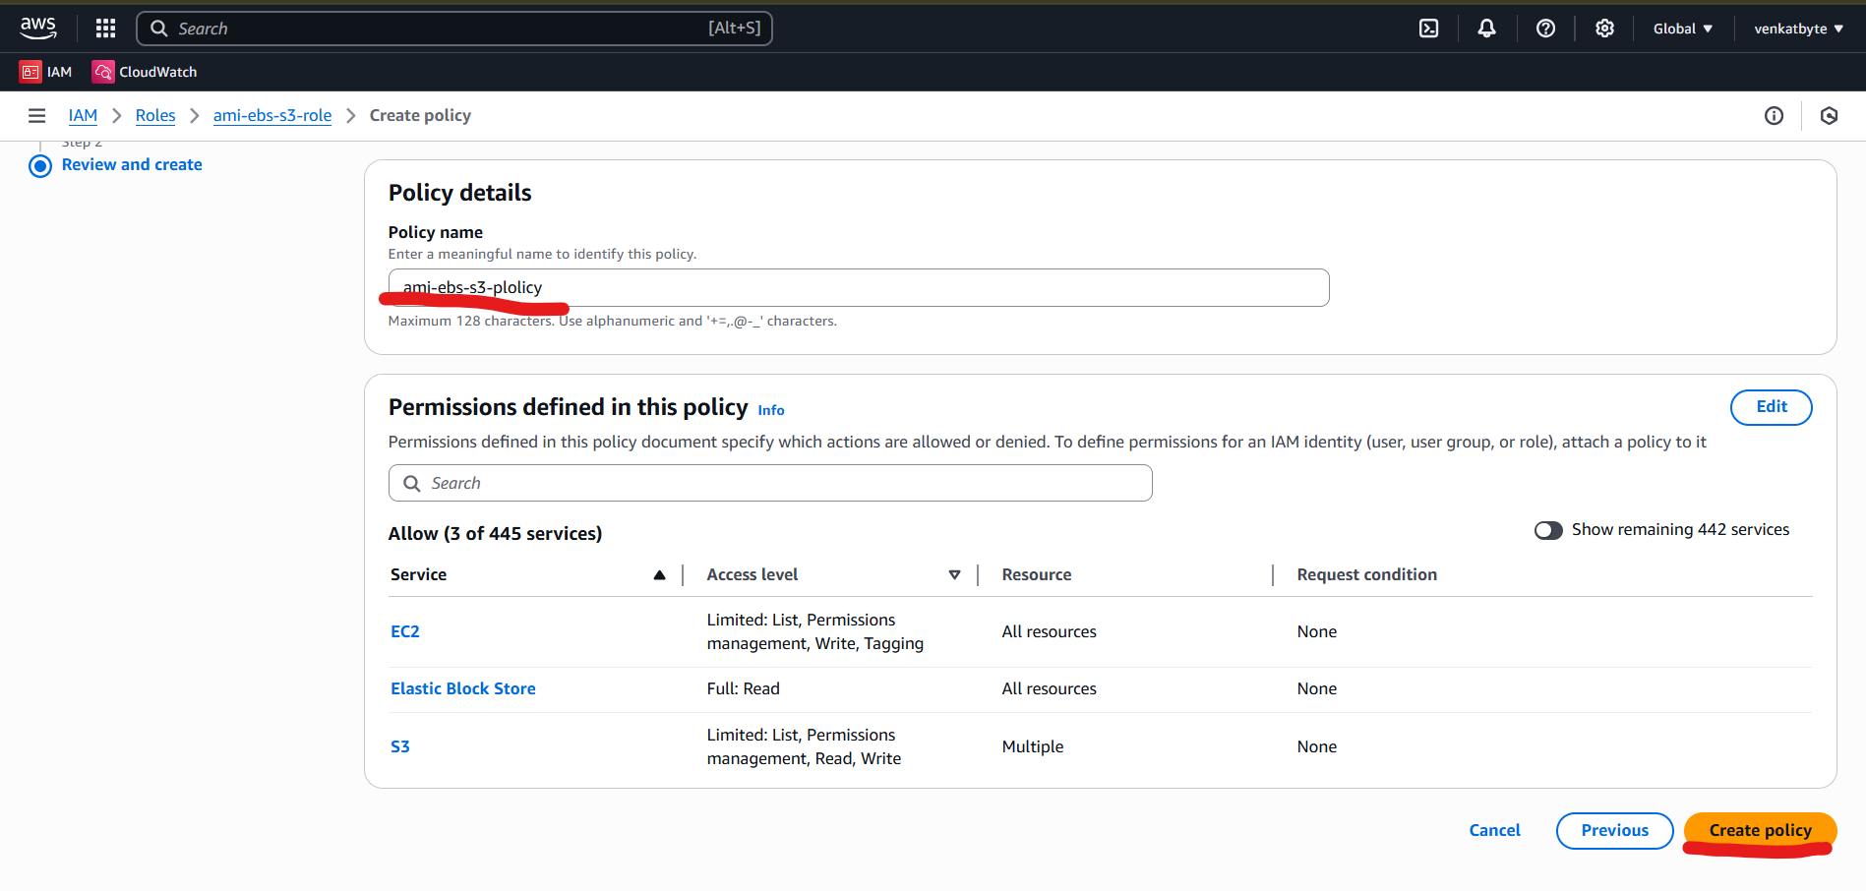

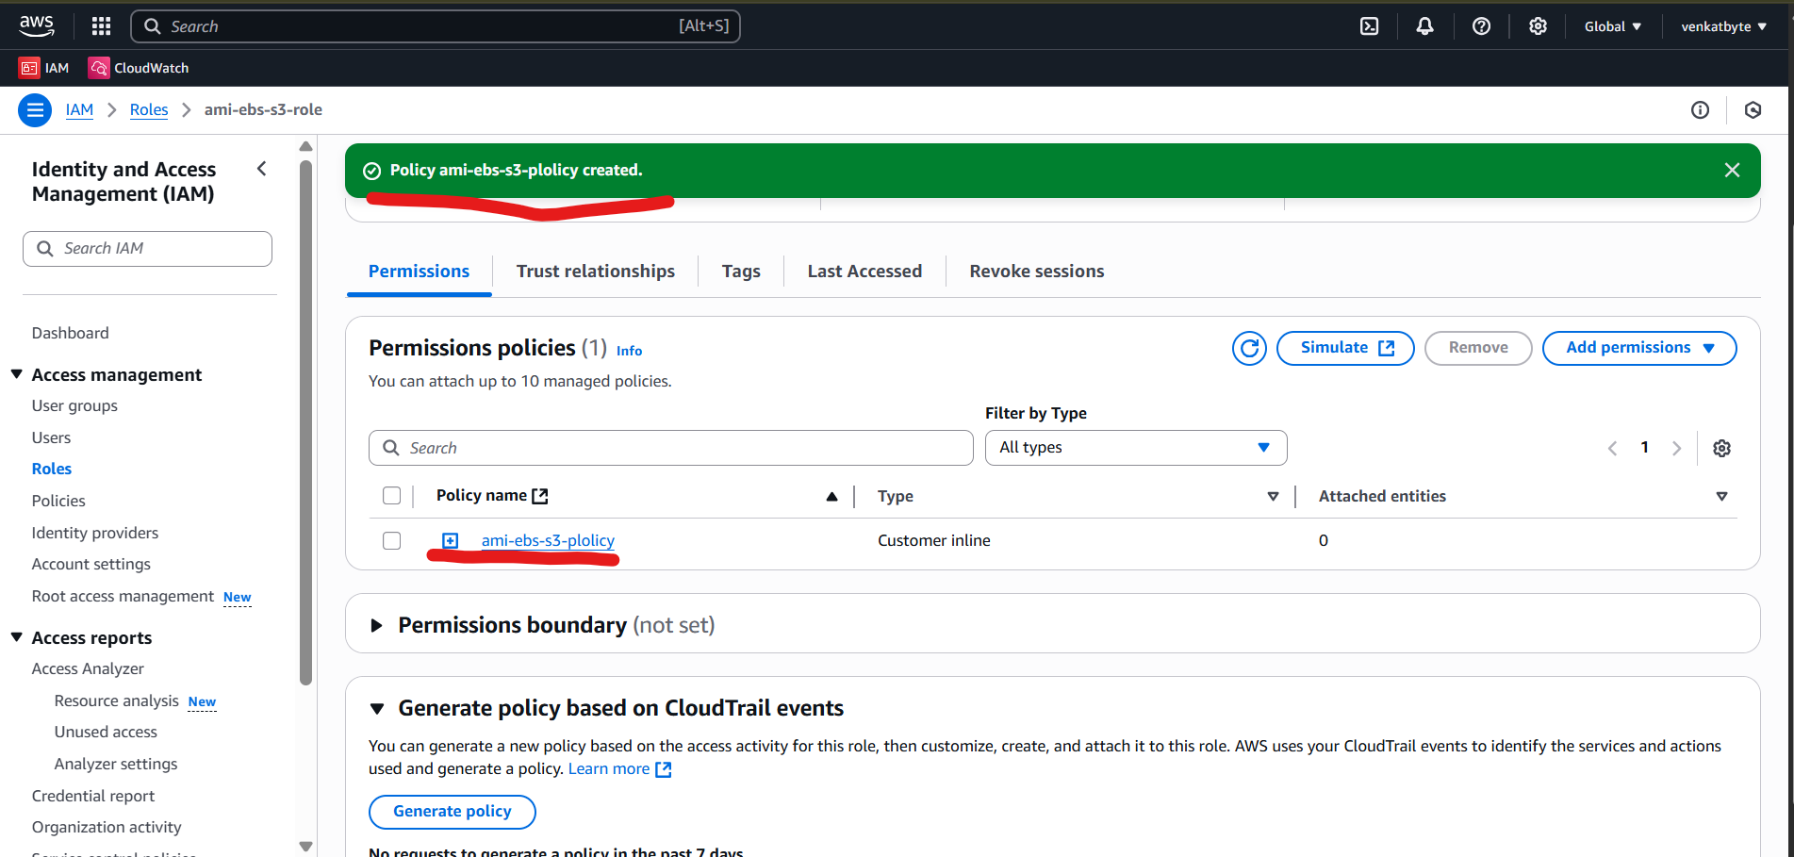

1. Next step is create EC2 Instance